**User’s Documentation**

*Calev*

**CPSC 473: Front End Engineering**

Instructor: Prof. Kenytt Avery

By:

Corrente, Matthew Steven

Jadhav, Snehal Shailendra

Maske, Snehal Vikas

Molina, Kevin William

Tran, Tien Hoang

Veliventi Naga, Venkatadatta Sai Santhosh

**What does our app do!**

If you are a consumer, this app is your perfect solution to book appointments with companies. Be it a Barber shop, restaurants or parlor.

If you are a business seeking the customers in timely manner and want to manage your calendar and time slots very well, you are at the right spots.

Consumer can visit the app to:

1. Find the company of your choice.
2. View the company’s calendar.
3. Book the appointment.

Business can visit the app to:

1. Update your customized calendar and booked appointments.
2. Select the time in weeks for which consumers can book the appointments.
3. View all the appointments on a single portal.

**General & Basic information**



* You are greeted with the login picture.
* You can use Signup and Login buttons to create/login into your account.

Sign Up

There are two sign up pages: company sign up and user sign up

User Sign up:

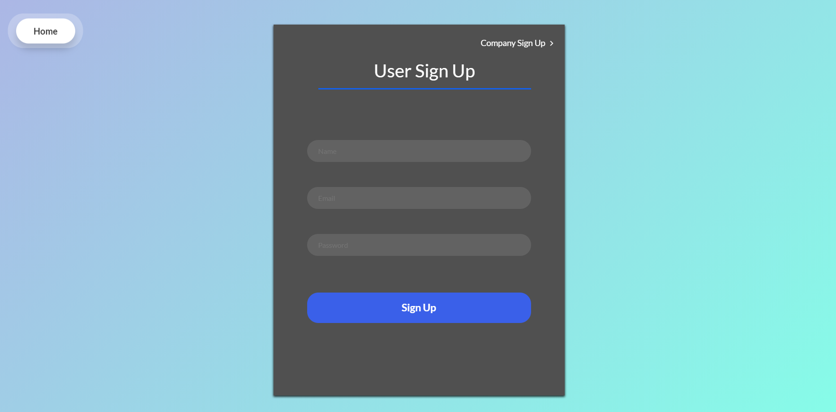

Company Sign up:

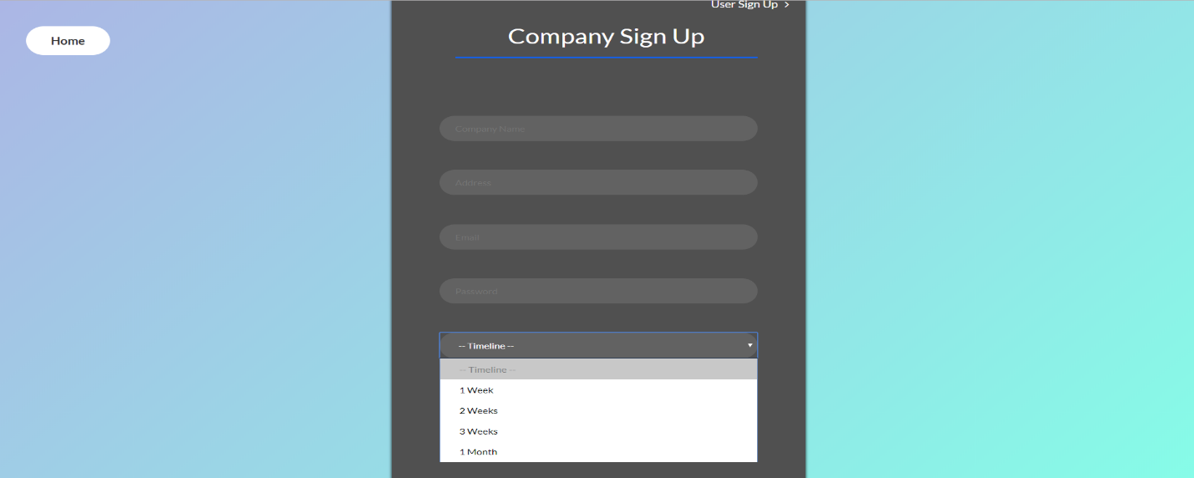

Notes:

1. All the fields are mandatory for sign up.
2. Company owner can select a timeline in weeks for which he wants the appointment slots to be available.

Sign In

You can login into the application by clicking on Log In button on homepage and entering your email address and password.

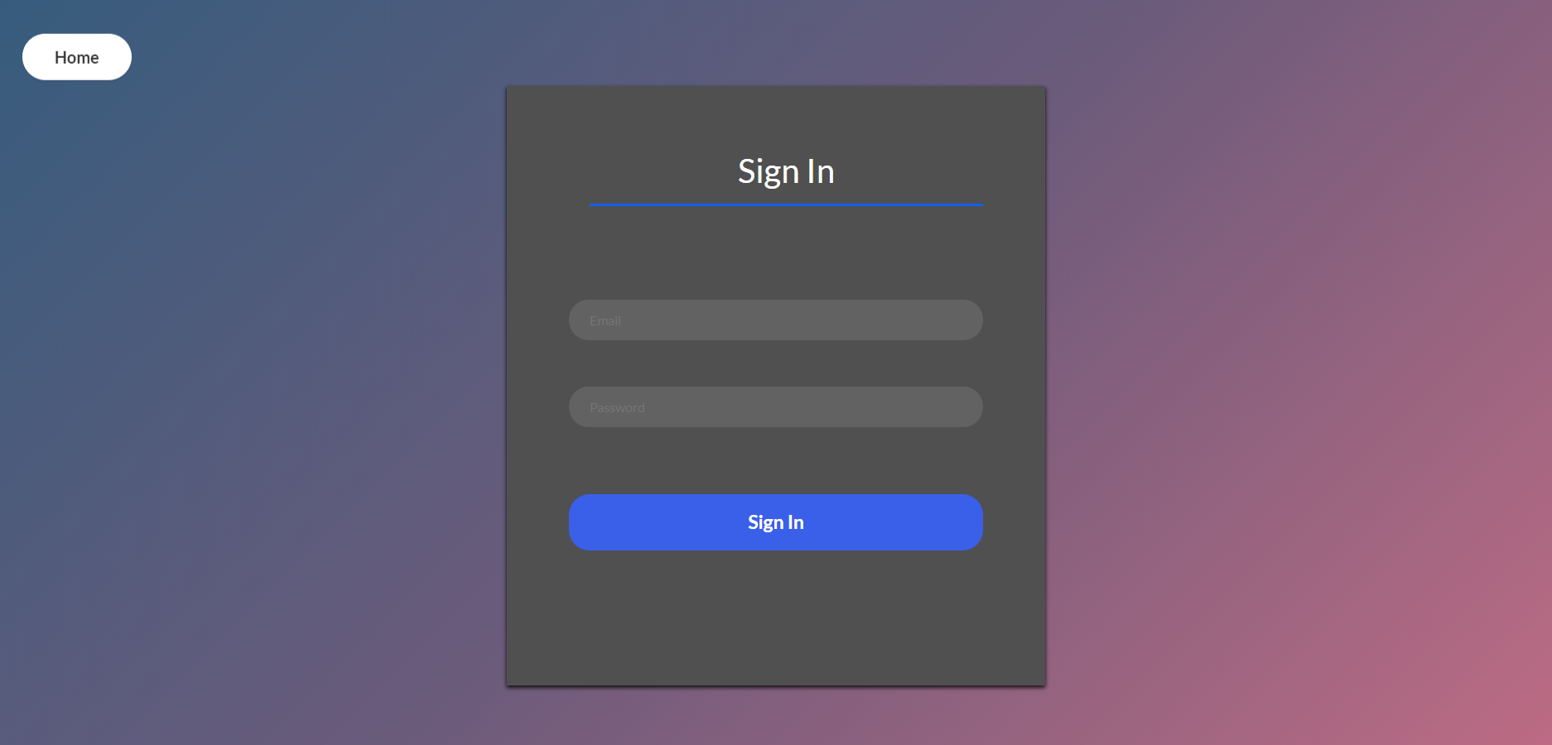

Logged In - User

After logging in, you have list of companies for which you can book the appointment by clicking on it.

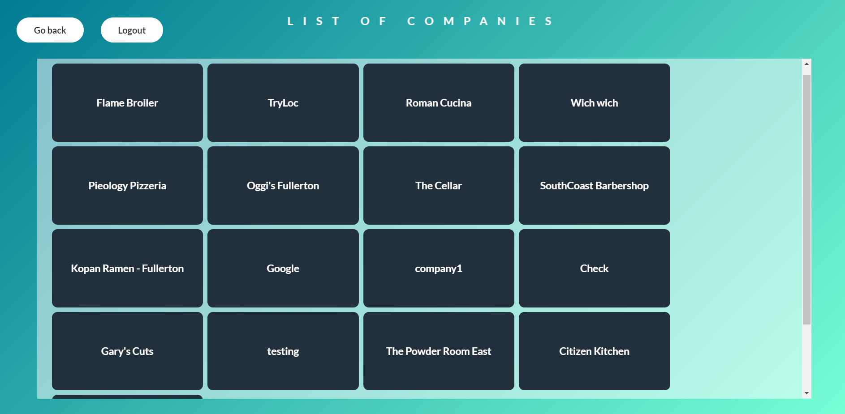

Appointments-User

Once clicked on the company, you can see the company’s calendar. You can manually select the date and time on the calendar by sampling dragging the mouse pointer.

Enter title for the event to create an appointment.

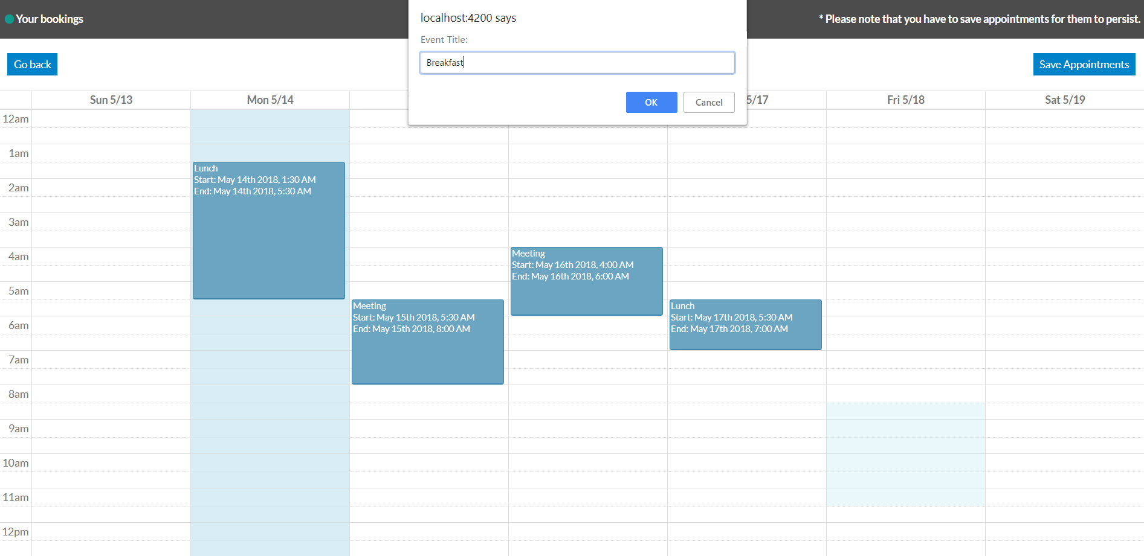

Click Save appointments to save the appointment to the database.

Notes:

1. You cannot create an event over already existing event
2. You cannot create an event for the past date.

Delete appointments-User

User can delete his own appointments. Just click on the event and you can see the option for deletion.

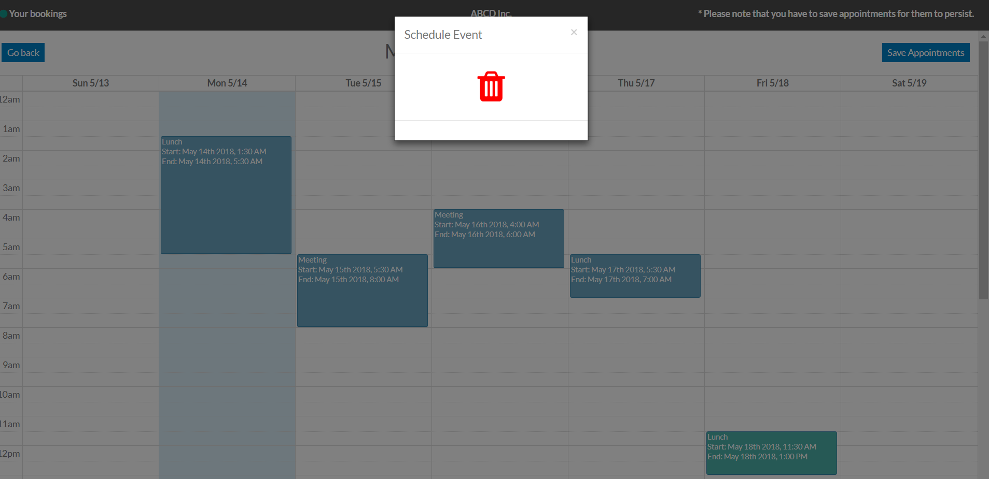

Click on Save Appointments to confirm your deletion.

Appointment Page-Company

When you are logged in as a Company official in the system, you can see list of appointments scheduled by the users.

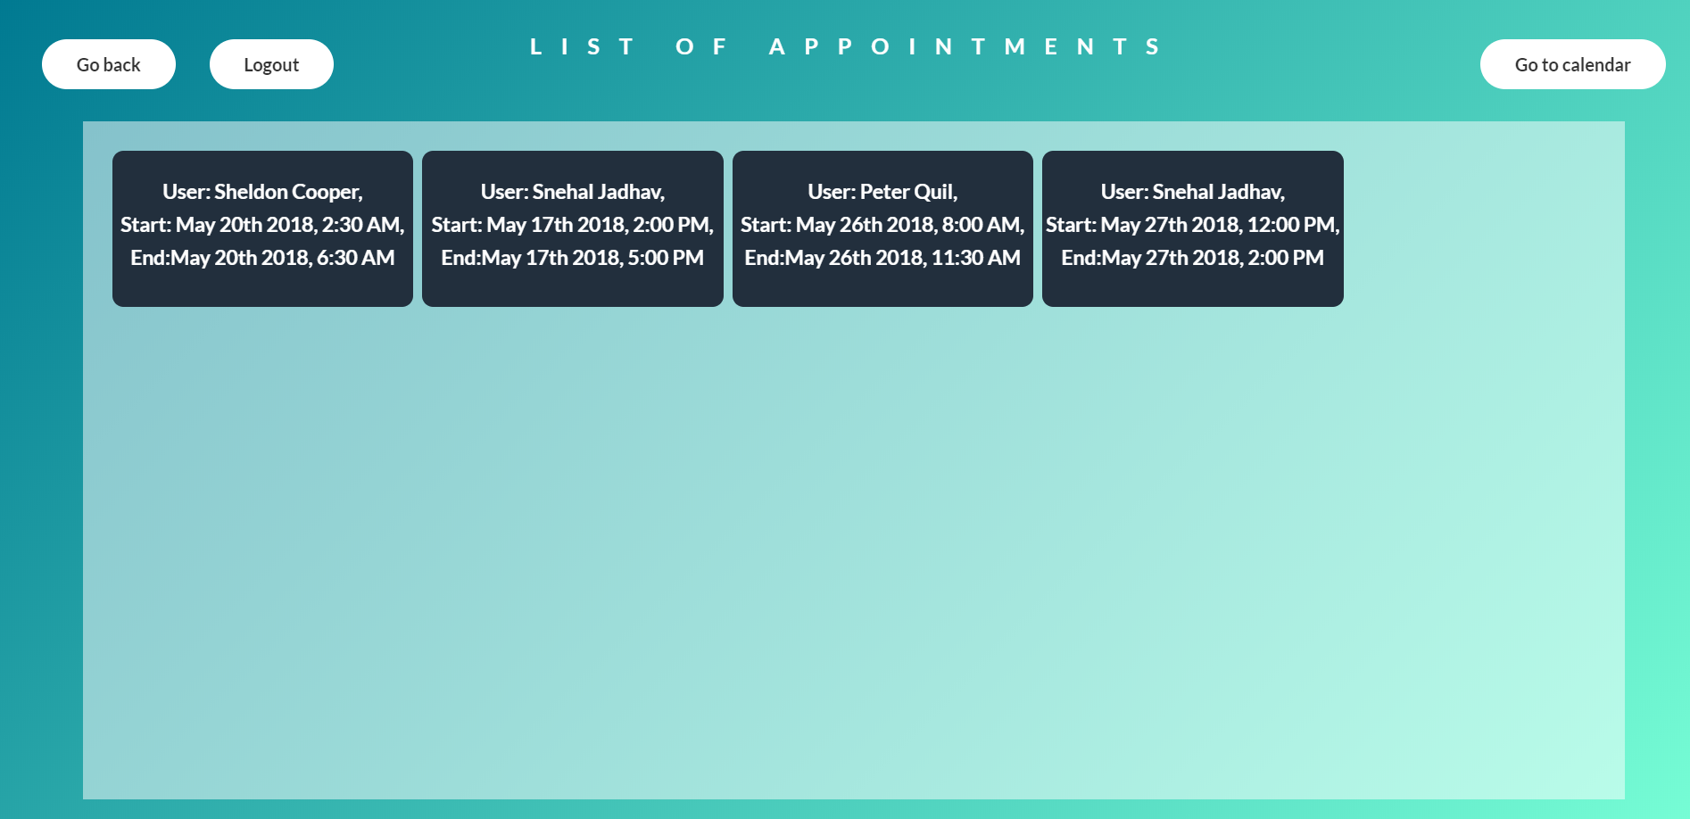

Go to Calendar-Company

Company’s official can view the calendar by clicking on Go to calendar button.

